Задача 9. Найти производную.
9.1. 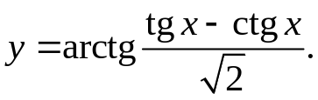
y'= 2(1/cos²x+1/sin²x) = 2cos²xsin²x = 2 _
2+(tgx-ctgx)² (sin⁴x+cos⁴x)sin²xcos²x sin⁴x+cos⁴x
9.2. 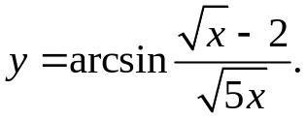
√(5x) _ √5(√x-2)
y'= 1 * 2√x 2√x = √5 = √5 _
√(1-(√x-2)²/(5x)) 5x 5x√(5x-(√x-2)²) 10x√(x+√x-1)

9.3. 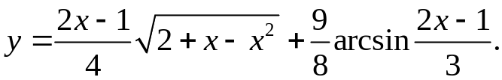
y'= 1/2*√(2+x-x²) – (2x-1)(1-2x) + 54 = 9 _
8√(2+x-x²) 24√(9-(2x-1)²) 4√(2+x-x²)
9.4. 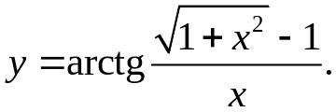
x² - √(1+x²)+1
y'= x² * √(1+x²) = √(1+x²) – 1 _
x²+(√(1+x²)-1)² x² 2√(1+x²)(x²-√(1+x²)+1)
9.5. 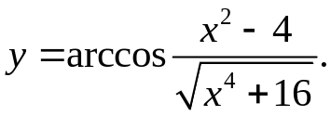
2x√(x⁴+16) – 2x(x²-4)
y'= - 1 * √(x⁴+16) = -√(x⁴+16) *
√(1-(x²-4)²/(x⁴+16)) x⁴+16 √(x⁴+16-x⁴+8x²-16)
* 2x(x⁴+16)-2x(x²-4) = x²-x⁴-20 _
(x⁴+16)√(x⁴+16) √2(x⁴+16)
9.6. 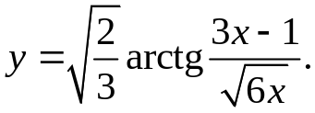
3√(6x)-3(3x-1)
y'= √(2/3) * √(6x) = 6x√2(18x-9x+3) = 3x+1 _
1+(3x-1)²/(6x) 6x 6x√3√(6x)√(6x+9x²-6x+1) √x(9x²+1)
9.7. 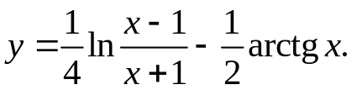
y'= x+1 * x+1-x+1 _ 1 = 1_
4(x-1) (x+1)² 2+2x² x⁴-1

9.8. 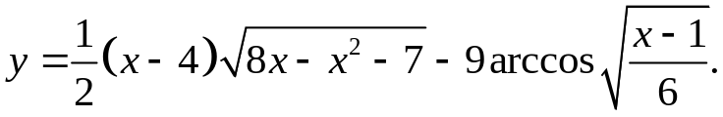
y'= 1/2*√(8x-x²-7)+ (x-4)(4-x) + 9√6 = 8x-23 + 9 _
2√(8x-x²-7) 2√(6x)√(6-x-1) 2√(8x-x²-7) 2√x√(5-x)
9.9. 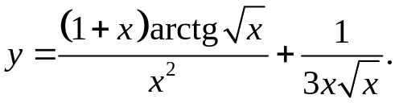
x²arctg√x+ (1+x)x² _ - 2x(1+x)arctg√x
y'= 2√x(1+x) _ √x+x/(2√x)_ =
x⁴ 3x³
= 1 _ 2arctg√x _ 2arctg√x _ 1 _
2x²√x x³ x² 3x²√x
9.10. 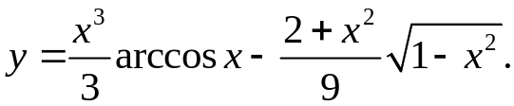
y'= x²arccosx - x³ _ 2x√(1-x²) + x(2+x²) =
3√(1-x²) 9 9√(1-x²)
= x²arccosx – 3x³+2x(1-x²)-2x-x³ = x²arccosx
9√(1-x²)
9.11. 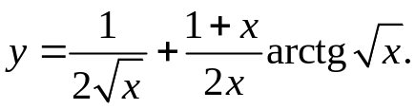
y'= - 1 + (x-1-x)arctg√x + x+1 = - arctg√x
4√x³ 2x² 4x√x 2x²
9.12. 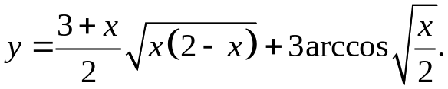
y'= 1/2*√(x(2-x))+(3+x)(2-2x) _ 3 _ =
4√(x(2-x)) 4√(x/2)√(1-x/2)
= 2x(2-x)+2(3+x)(1-x) _ 3 _ = -x² _
4√(x(2-x)) 2√(x(2-x)) √(x(2-x))
9.13. 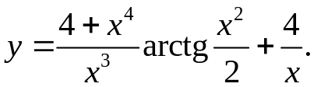
y'= (4x³*x³-3x²(4+x⁴))arctg(x²/2) + (4+x⁴)x – 4/x² =
x⁶ x³
= (x⁴-12)arctg(x²/2) + 4(x⁴-3)
x⁴ x²(4+x⁴)
9.14. 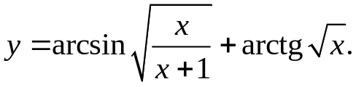
y'= √x(x+1-x) + 1 _ = -1 _
2√(1-x/(x+1))√(x+1)(x+1)² 2(x+1)√x 2(x+1)²√x
9.15. 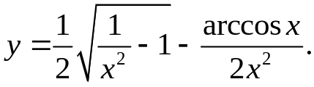
y'= -2 + 2x² _ 2arccosx = -x+2x _ arccosx = 1 _ arccosx
4x³√(1/x²-1) 2x⁴√(1-x²) 2x⁷ 2x³√(1-x²) x⁷ 2x²√(1-x²) x⁷
9.16. 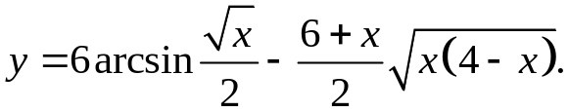
y'= 6 – x/2*√(x(4-x)) – (6+x)(4-2x) = 3 – x/2*√(x(4-x)) – (6+x)(2-x) =
4√x√(1-x/4) 4√(x(4-x)) √(x(4-x)) 4√(x(4-x))
= x³-3x²+4x-6
2√(x(4-x))
9.17. 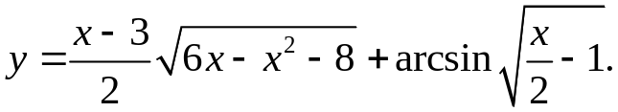
y'= x/2*√(6x-x²-8)+ (x-3)(3-x) + 1 =
2√(6x-x²-8) 4√(x/2-1)√(1-x/2+1)
= 6x²-x³-8x-x²+9+ 2 = 5x²-x³-8x+10
2√(6x-x²-8) 4√((4-x)(x-2)) 2√(6x-x²-8)
9.18. 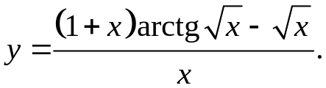
arctg√x+ 1+x _ 1_
y'= 2(1+x)√x 2√x = arctg√x
x² x²
9.19. 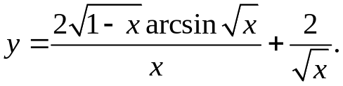
-arcsin√x+ √(1-x)_
y'= √(1-x) √(x(1-x)) = -arcsin√x+ 1 _ _ 1_
x² x²√(1-x) x²√x x√x
9.20. 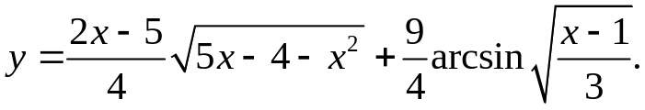
y'= x/2*√(5x-4-x²)+(2x-5)(5-2x)+ 9√3 = 16x²-16x-4x³-4x²+25+12√3√(x-1)
8√(5x-4-x²) 12√(3-x+1) 8√(5x-4-x²)
9.21. 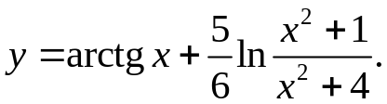
y'= 1 +5(x²+4)(2x(x²+4)-2x(x²+1)) = x²+5x+4 _
1+x² 6(x²+1)(x²+4) (x²+1)(x²+4)
9.22. 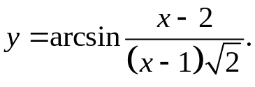
y'= √2(x-1)-√2(x-2) = 1 _
2(x-1)²√(1-(x-2)²/(2(x-1)²)) (x-1)√(x²-2)
9.23. 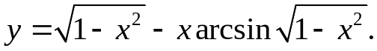
y'= -x/√(1-x²) - arcsin√(1-x²)+2x²/√(1-1+x²)= -x/√(1-x²) - arcsin√(1-x²)+2x

9.24. 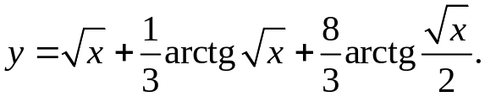
y'= 1 + 1 + 16 = 1 + 1 + 4 _
2√x 6(1+x)√x 12(2+x)√x 2√x 6(1+x)√x 3(2+x)√x
9.25. 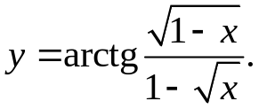
√x-1 + √(1-x)
y'= (1-√x)² * 2√(1-x) 2√x = x-√x+1-x = 1 _
(1-√x)²+(1-x) (1-√x)² 2√(x(1-x))(1-√x)(1-√x+1+√x) 4√(x(1-x))
9.26. 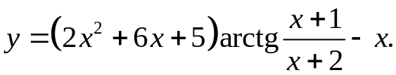
y'= (4x+6)arctg((x+1)/(x+2))+ (2x²+6x+5)(x+2-x-1) – 1 =
(x+2)²(1+((x+1)/(x+2))²)
= (4x+6)arctg((x+1)/(x+2))

9.27. 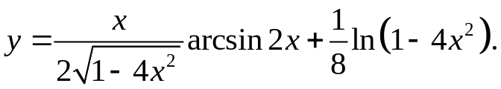
2√(1-4x²)+ 2x² _
y'= √(1-4x²) * arcsin2x + 2x _ 8x =
4(1-4x²) 2√(1-4x²) 8(1-4x²)
= 2(1-4x²)+2x²arcsin2x+ x _ x = 1-3x²arcsin2x
4(1-4x²) 1-4x² 1-4x² 2-8x²
9.28. 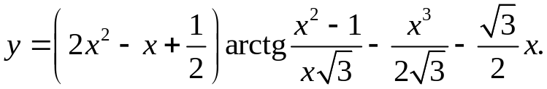
y'= (4x-1)arctg((x²-1)/(x√3))+(2x²-x+1/2)(2x²√3-√3(x²-1)) _ 3x² _ √3 =
3x²(1+(x²-1)²/(3x²)) 2√3 2
= (4x-1)arctg((x²-1)/(x√3))+√3(2x²-x+1/2)(x²+1) _ 3x² _ √3
3x²+(x²-1)² 2√3 2
9.29. 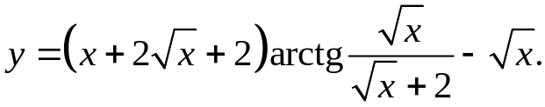
y'= (1+1/√x)arctg(√x/(√x+2))+ x+2√x+2 _ 1 = (1+1/√x)arctg(√x/(√x+2))
√x((√x+2)²+x) 2√x
9.30. 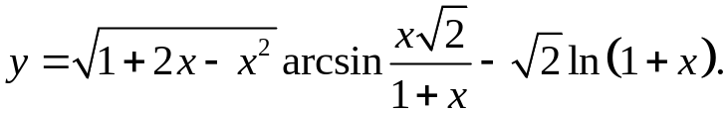
y'= 1-x arcsinx√2+√(1+2x-x²)(√2(1+x)-x√2) = 1-x arcsinx√2+√2_
√(1+2x-x²) 1+x (1+x)²√(1-2x²/(1+x)²) √(1+2x-x²) 1+x 1+x

9.31. 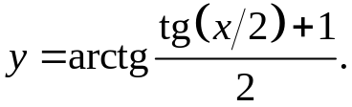
y'= 4 = 1 _
4cos²(x/2)(4+(tg(x/2)+1)²) cos²(x/2)(4+(tg(x/2)+1)²)

